|  |  |
| --- | --- |
| VISUAL | Information  Retrieval |

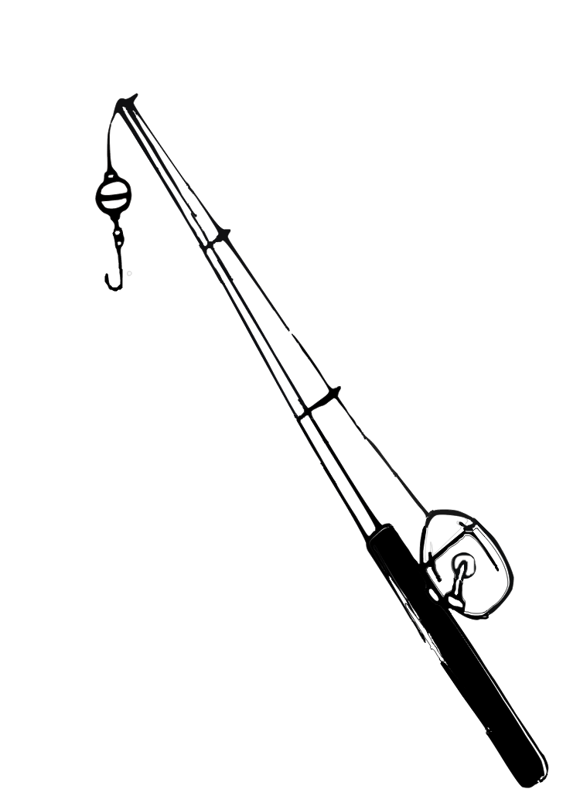

COMS W4735: Visual Interfaces to Computers

Assignment 2

due: 3/17/2015

Nina Baculinao

uni: nb2406

Table of Contents

Introduction 2

Color Measure 3

Bin Size 3

Black Threshold 3

Results 3

Gross Texture Matching 18

Texture Measure 18

Bin Size 18

Black Threshold 18

Results 18

Combine Similarities, and Cluster 19

Similarity Measure 33

Complete Link vs. Single Link Clustering 33

Results 33

Creative Step 33

Performance Measure 33

Friend Results 33

System Results 33

Code Listing 33

visret.py 33

performance.py 33

Appendix: User Studies 34

# Introduction

The goal of the Visual Information Retrieval system is to explore different ways of deciding the degree of similarities between actual images.

Gross Color Matching

## Color Measure

## Bin Size

## Black Threshold

## Results

The goal of the Visual Combination Lock is to recognize a sequence of visual images as a password. It builds off the basic assignment of having to identify the combination of a fist in the center of a table and a splayed palm in the corner. It adds one more token to the password, a splayed palm moved to another corner of the image. From there, it builds the vocabulary to include recognition for two, three and four upheld fingers. Finally, it uses this foundation of gesture recognition to build a quasi real time system of password verification of capturing a series of 3 pictures 5 second intervals through a webcam and identifying if the user has placed their hands in the predetermined sequence of locations and poses.

Best Match Bad

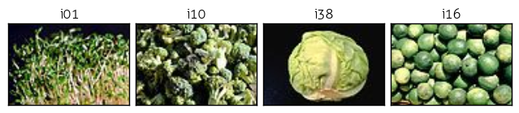

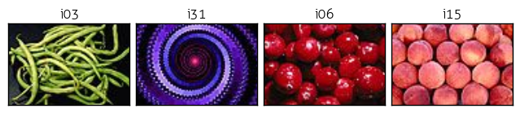

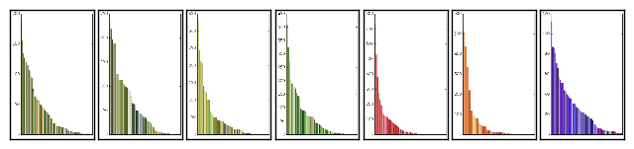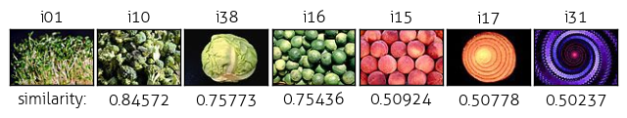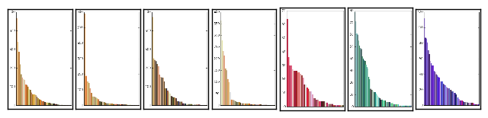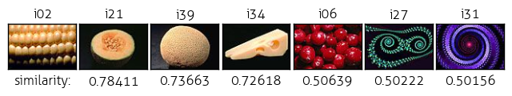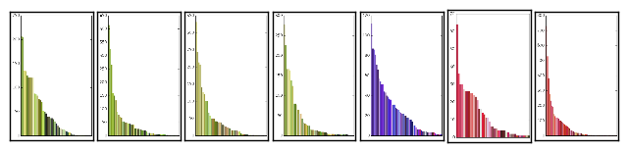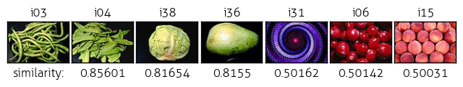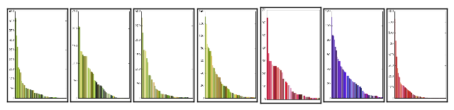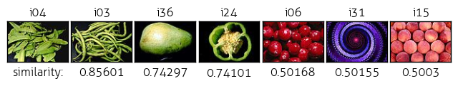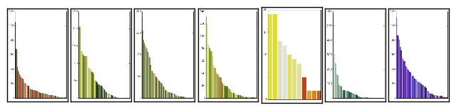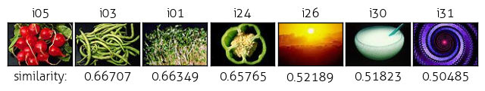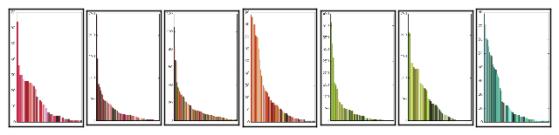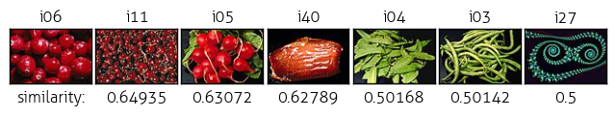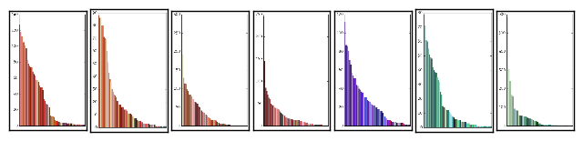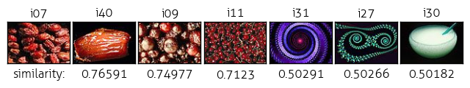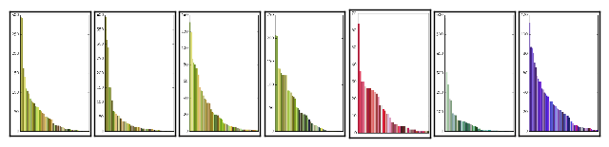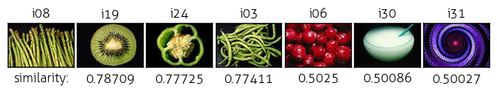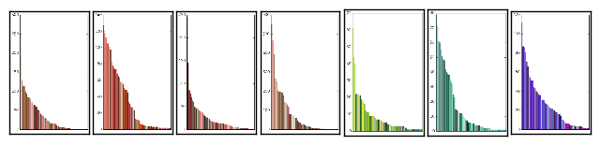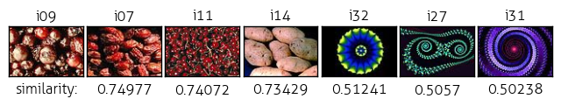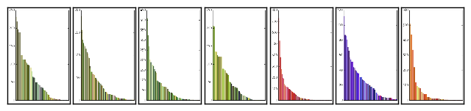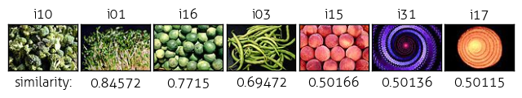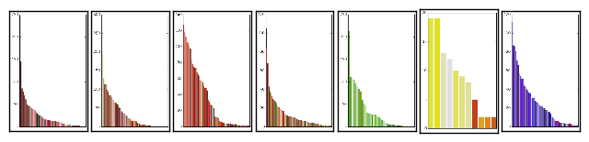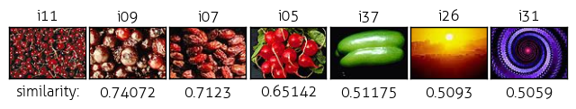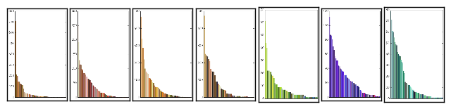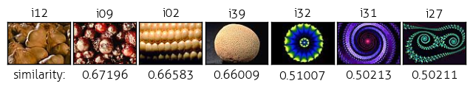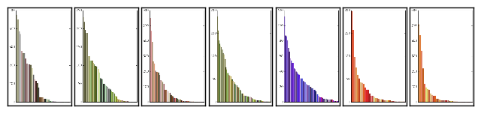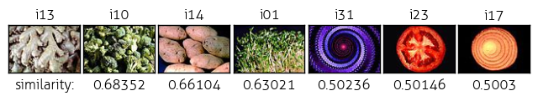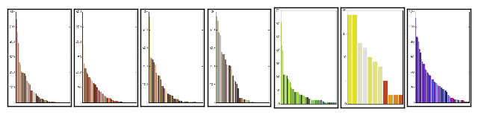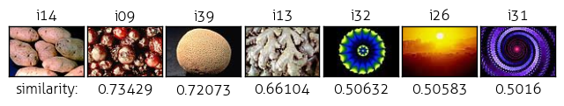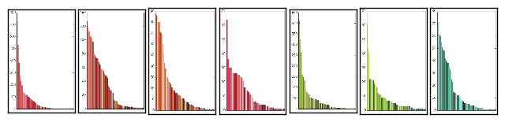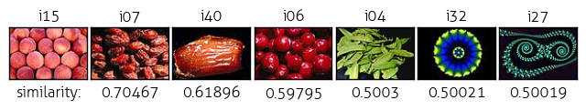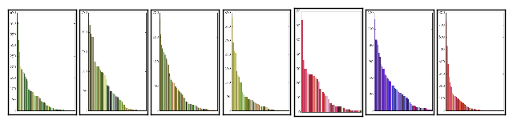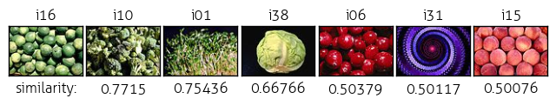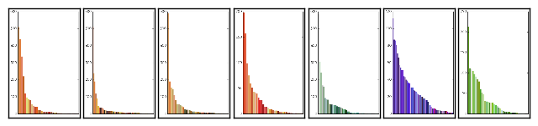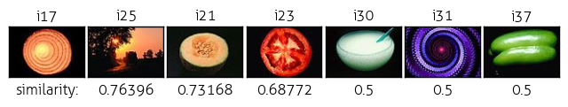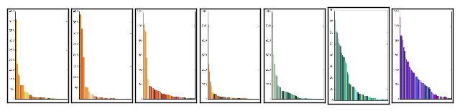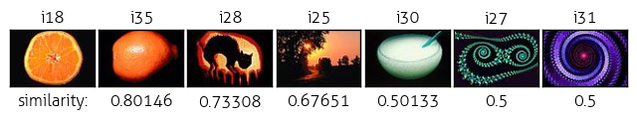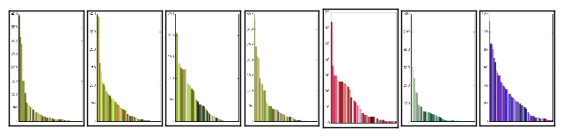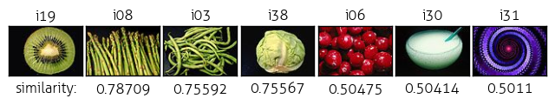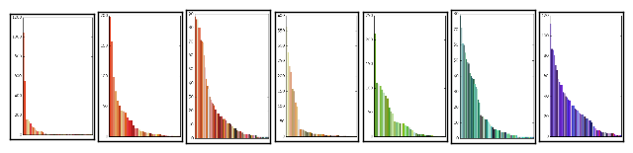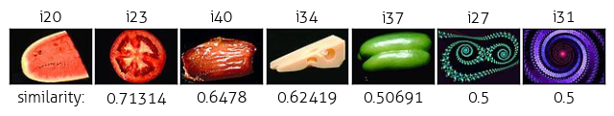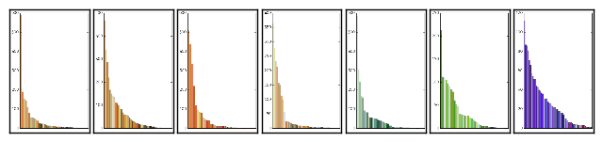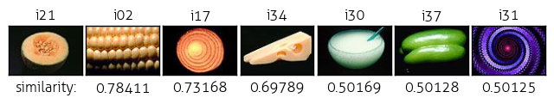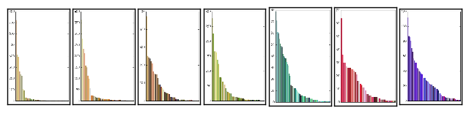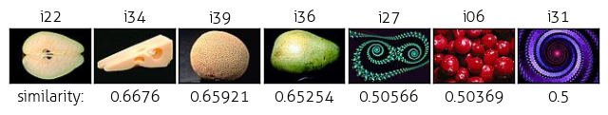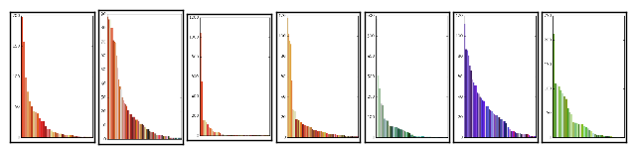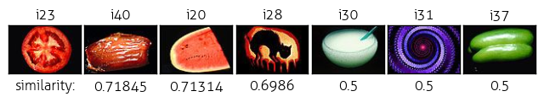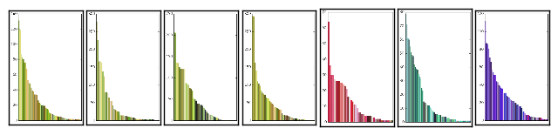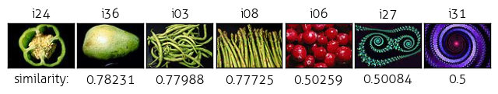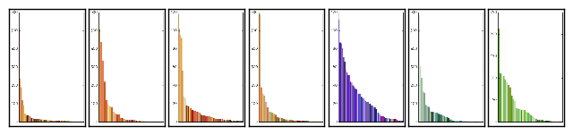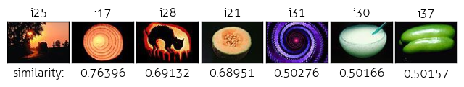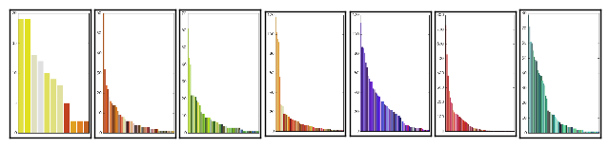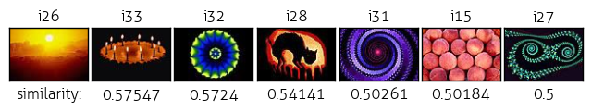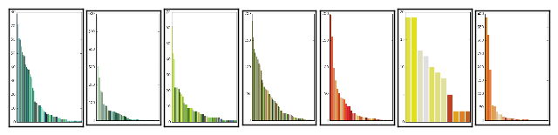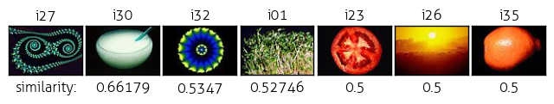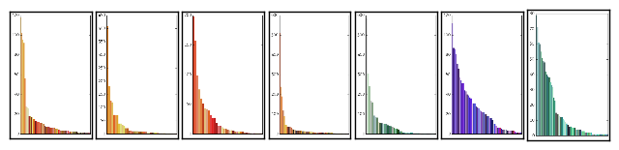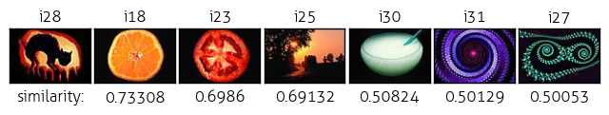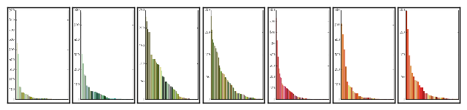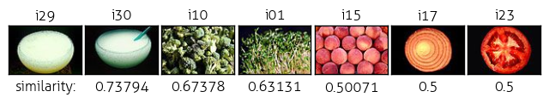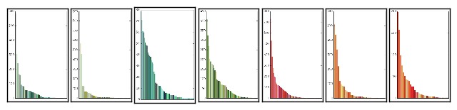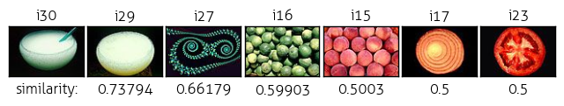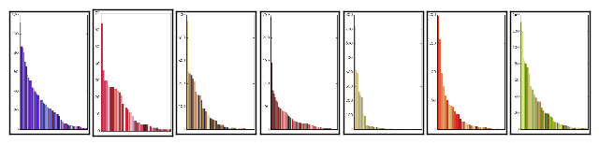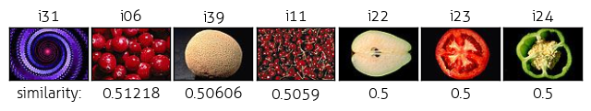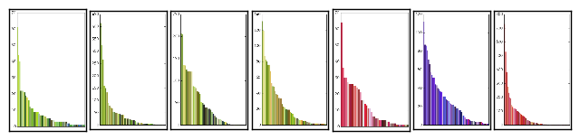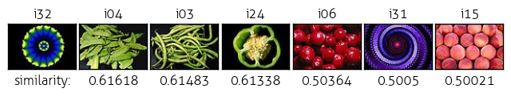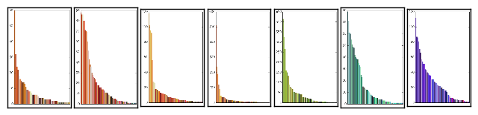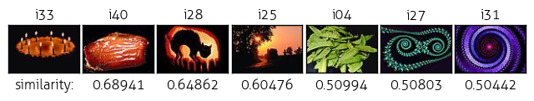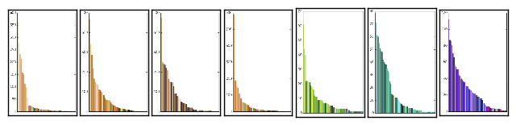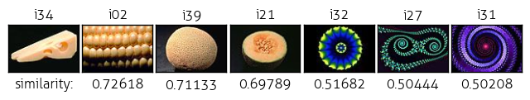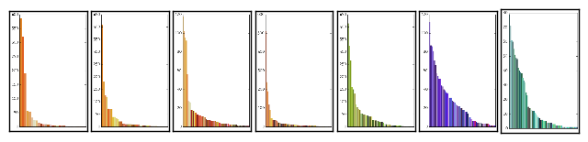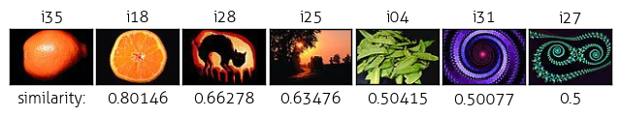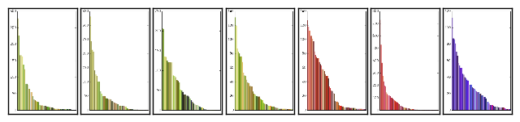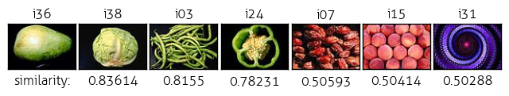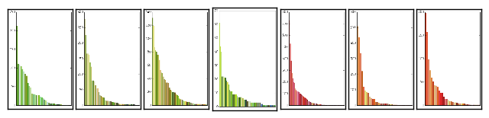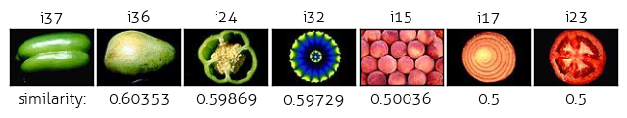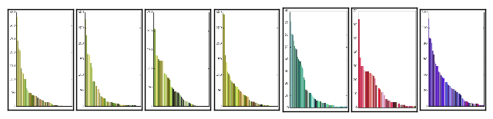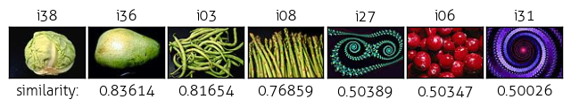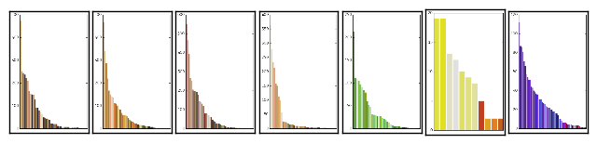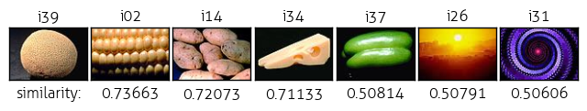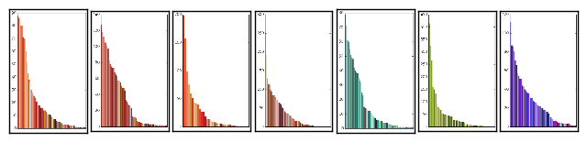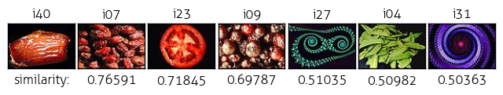

# Gross Texture Matching

## Texture Measure

## Bin Size

## Black Threshold

## Results

|  |  |  |  |  |  |  |
| --- | --- | --- | --- | --- | --- | --- |
| (i-1,j-1) | (i-1,j) | (i-1,j+1) |  | Top left | Top center | Top right |
| (i,j-1) | (i,j) | (i,j+1) |  | Center right | center | Center left |
| (i+1,j-1) | (i+1,j) | (i+1,j+1) |  | Bottom right | Bottom center | Bottom left |

i21



blk thresh 40, 15, 20, none

# Combine Similarities, and Cluster

## Similarity Measure

## Complete Link vs. Single Link Clustering

## Results

# Creative Step

## Performance Measure

## Friend Results

## System Results

# Code Listing

## visret.py

## performance.py

# Appendix: User Studies

